PROJECT DESIGN PHASE
Problem – Solution Fit Document
Automated Network Request Management in ServiceNow
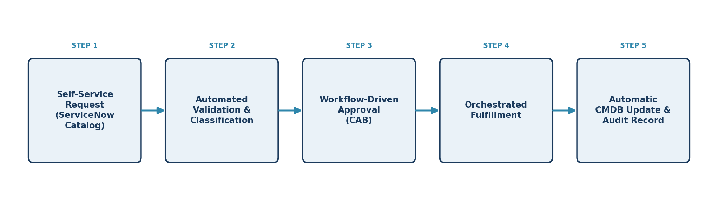
Date | 29 July 2026
Team ID | [Enter Team ID]
Project Name | Automated Network Request Management in ServiceNow
Maximum Marks | 2 Marks

Problem – Solution Fit Template
The Problem–Solution Fit confirms that a real, validated customer problem has been identified, and that the proposed solution genuinely solves it. It surfaces the behavioural patterns behind today's network change request process and clarifies what will work — and why — before implementation begins.
Automating network request management in ServiceNow enhances operational efficiency by streamlining workflows, reducing manual interventions, and ensuring real-time updates. This project implements a fully automated and scalable network change management process in ServiceNow to automate user-initiated network requests, ensuring rapid fulfillment, audit-ready change records, and accurate configuration tracking.

Purpose
• Solve the network change request problem in a way that fits how requesters, approvers, and engineers actually work today.
• Succeed faster by tapping into the existing ServiceNow platform already used across the organisation.
• Sharpen the automation and communication strategy around the right triggers (e.g., onboarding, new deployments, audits).
• Increase trust in IT by solving frequent, costly, or urgent network request pain points.
• Understand the current, largely manual situation in order to design a fully automated replacement.

Current State vs. Future State
The diagram below contrasts today's manual, fragmented process with the automated, ServiceNow-native workflow this project delivers.
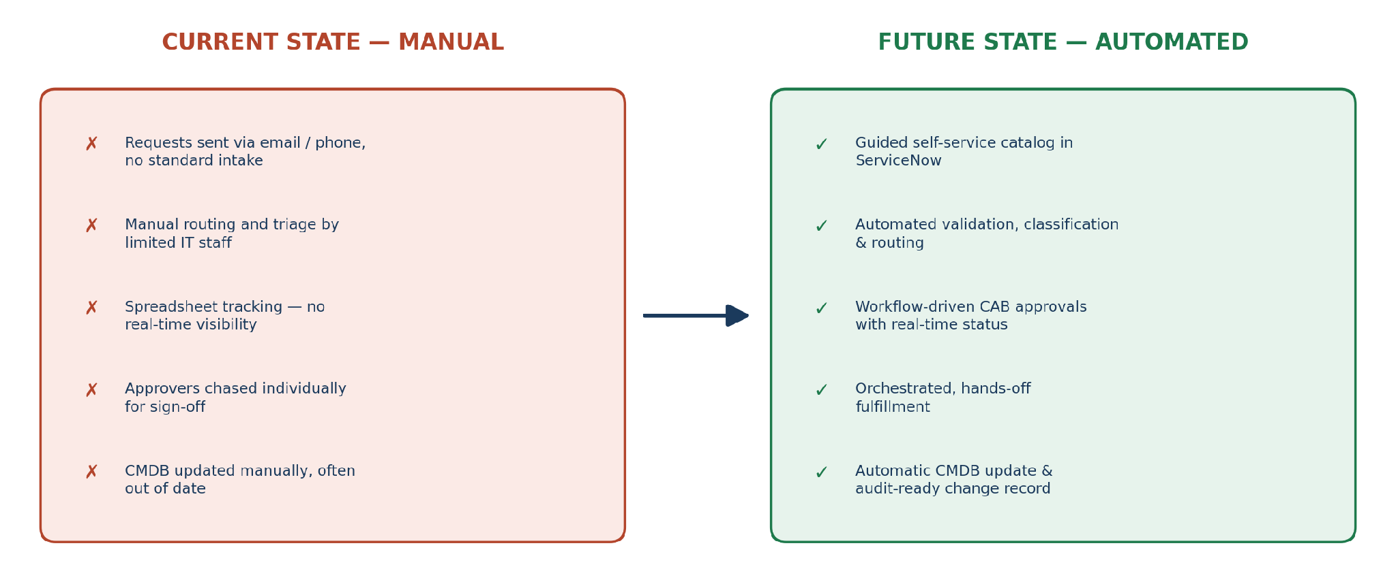

Problem – Solution Fit Canvas
PURPOSE / VISION
Automated Network Request Management in ServiceNow
Automate and streamline network change request management in ServiceNow — reducing manual intervention and ensuring real-time updates — so every user-initiated network request is fulfilled rapidly, tracked with an audit-ready change record, and reflected accurately in the configuration data.
CS Customer Segment(s)  • Enterprise employees, IT support staff, and network engineers who need network changes made (VLANs, firewall rules, port access, Wi-Fi access) as part of daily work.  • Change Approvers / CAB members and IT Compliance & Audit teams who rely on the process outputs. | CC Customer Constraints  • Limited IT staffing available to manually triage and fulfill every request.  • Incomplete or inconsistent CMDB data quality.  • Defined change windows and maintenance policies restrict when changes can be made.  • Regulatory/compliance mandates for documented approvals and audit trails. | AS Available Solutions  • Manual email or phone requests routed by hand to the network team.  • Spreadsheet-based tracking with no real-time visibility or audit trail.  • Basic ServiceNow ticket without dedicated workflow, validation, or CMDB integration.  • Standalone network-automation scripts disconnected from the ITSM system of record.
J&P Jobs-to-be-Done / Problems  • Employees need a fast, simple way to request network changes without needing networking expertise.  • IT teams need requests validated, correctly classified, and free of duplicate or incomplete data.  • Approvers need clear, risk-assessed information to approve or reject changes quickly.  • Engineers need to implement changes accurately and keep configuration records current.  • Compliance teams need traceable, audit-ready records for every change. | RC Problem Root Cause  • The network change process evolved organically through email and ad-hoc tickets rather than being designed as a structured ServiceNow workflow.  • As request volume grew, there was no standardised intake, validation, or CMDB integration — so requests are captured inconsistently, routed manually, and tracked poorly end to end. | BE Behaviour  • Requesters email the network team or raise a generic IT ticket, then follow up repeatedly by phone or chat for status.  • Engineers track pending changes in spreadsheets or personal notes.  • Approvers are chased individually for sign-off.
TR Triggers  • A new employee joins and needs network / VPN access.  • A business unit deploys a new application requiring firewall or port changes.  • Growing volume of manual, ticket-based requests causes delays.  • Audit findings or compliance gaps trace back to undocumented changes.  • Network incidents are traced to unrecorded, ad-hoc changes. | SL Your Solution  • A fully automated, scalable network change management workflow built natively in ServiceNow — combining a guided self-service catalog, automated validation and routing, workflow-driven approvals, orchestrated fulfillment, and automatic CMDB updates — to ensure rapid fulfillment, audit-ready change records, and accurate configuration tracking for every request. | CH Channels of Behaviour  • Online: Email, ServiceNow portal / ticketing, Slack / Teams requests, network monitoring dashboards.  • Offline: Phone calls to the network team, in-person requests at CAB meetings, manual change forms in some legacy processes.
EM Emotions: Before / After
• Before: frustrated by slow manual approval chains, anxious about whether the request was even routed correctly, unsure of status or timelines.
• After: confident the request was fulfilled correctly, reassured by real-time visibility, relieved that a complete audit trail exists automatically.

